| **Variable** | **by Variable** | **Correlation** | **Count** | **Lower 95%** | **Upper 95%** | **Signif Prob** |  |
| --- | --- | --- | --- | --- | --- | --- | --- |
| ZIP_2 | zip | 0.7467 | 500 | 0.7052 | 0.7831 | <.0001* |  |
| Restaurant | zip | -0.0602 | 500 | -0.1471 | 0.0276 | 0.1788 |  |
| Restaurant | ZIP_2 | -0.0259 | 500 | -0.1133 | 0.0620 | 0.5639 |  |
| RES_VISITS | zip | -0.0906 | 500 | -0.1769 | -0.0030 | 0.0428* |  |
| RES_VISITS | ZIP_2 | 0.0065 | 500 | -0.0812 | 0.0941 | 0.8846 |  |
| RES_VISITS | Restaurant | 0.5955 | 500 | 0.5358 | 0.6493 | <.0001* |  |
| Webstore_Spend | zip | -0.1043 | 500 | -0.1903 | -0.0168 | 0.0196* |  |
| Webstore_Spend | ZIP_2 | -0.0186 | 500 | -0.1061 | 0.0692 | 0.6778 |  |
| Webstore_Spend | Restaurant | 0.4534 | 500 | 0.3808 | 0.5204 | <.0001* |  |
| Webstore_Spend | RES_VISITS | 0.2943 | 500 | 0.2121 | 0.3724 | <.0001* |  |
| WEB_VISITS | zip | -0.0928 | 500 | -0.1790 | -0.0051 | 0.0381* |  |
| WEB_VISITS | ZIP_2 | -0.0226 | 500 | -0.1101 | 0.0652 | 0.6142 |  |
| WEB_VISITS | Restaurant | 0.2078 | 500 | 0.1223 | 0.2902 | <.0001* |  |
| WEB_VISITS | RES_VISITS | 0.1839 | 500 | 0.0978 | 0.2673 | <.0001* |  |
| WEB_VISITS | Webstore_Spend | 0.6119 | 500 | 0.5540 | 0.6640 | <.0001* |  |
| THIRD_SPEND | zip | -0.0053 | 500 | -0.0929 | 0.0824 | 0.9061 |  |
| THIRD_SPEND | ZIP_2 | -0.0668 | 500 | -0.1536 | 0.0211 | 0.1360 |  |
| THIRD_SPEND | Restaurant | -0.0427 | 500 | -0.1299 | 0.0451 | 0.3405 |  |
| THIRD_SPEND | RES_VISITS | -0.0801 | 500 | -0.1666 | 0.0076 | 0.0735 |  |
| THIRD_SPEND | Webstore_Spend | -0.0059 | 500 | -0.0935 | 0.0819 | 0.8958 |  |
| THIRD_SPEND | WEB_VISITS | -0.0409 | 500 | -0.1281 | 0.0470 | 0.3616 |  |
| THIRD_VISITS | zip | 0.0465 | 500 | -0.0414 | 0.1336 | 0.2999 |  |
| THIRD_VISITS | ZIP_2 | -0.0143 | 500 | -0.1019 | 0.0734 | 0.7491 |  |
| THIRD_VISITS | Restaurant | -0.0379 | 500 | -0.1252 | 0.0500 | 0.3978 |  |
| THIRD_VISITS | RES_VISITS | -0.0846 | 500 | -0.1711 | 0.0031 | 0.0586 |  |
| THIRD_VISITS | Webstore_Spend | -0.0034 | 500 | -0.0911 | 0.0843 | 0.9394 |  |
| THIRD_VISITS | WEB_VISITS | -0.0103 | 500 | -0.0979 | 0.0774 | 0.8180 |  |
| THIRD_VISITS | THIRD_SPEND | 0.7422 | 500 | 0.7001 | 0.7792 | <.0001* |  |
| Age | zip | -0.0522 | 500 | -0.1393 | 0.0356 | 0.2436 |  |
| Age | ZIP_2 | -0.0659 | 500 | -0.1527 | 0.0220 | 0.1414 |  |
| Age | Restaurant | -0.0033 | 500 | -0.0909 | 0.0845 | 0.9422 |  |
| Age | RES_VISITS | 0.0045 | 500 | -0.0832 | 0.0922 | 0.9194 |  |
| Age | Webstore_Spend | -0.0368 | 500 | -0.1240 | 0.0511 | 0.4122 |  |
| Age | WEB_VISITS | -0.0037 | 500 | -0.0914 | 0.0840 | 0.9337 |  |
| Age | THIRD_SPEND | -0.0827 | 500 | -0.1692 | 0.0050 | 0.0647 |  |
| Age | THIRD_VISITS | -0.0768 | 500 | -0.1634 | 0.0109 | 0.0862 |  |
| MARR_BIN | zip | 0.0849 | 500 | -0.0029 | 0.1713 | 0.0579 |  |
| MARR_BIN | ZIP_2 | 0.1090 | 500 | 0.0215 | 0.1948 | 0.0147* |  |
| MARR_BIN | Restaurant | -0.0796 | 500 | -0.1661 | 0.0082 | 0.0755 |  |
| MARR_BIN | RES_VISITS | -0.0797 | 500 | -0.1662 | 0.0081 | 0.0750 |  |
| MARR_BIN | Webstore_Spend | -0.0148 | 500 | -0.1023 | 0.0730 | 0.7419 |  |
| MARR_BIN | WEB_VISITS | -0.0054 | 500 | -0.0930 | 0.0824 | 0.9049 |  |
| MARR_BIN | THIRD_SPEND | -0.0129 | 500 | -0.1005 | 0.0748 | 0.7728 |  |
| MARR_BIN | THIRD_VISITS | -0.0280 | 500 | -0.1154 | 0.0599 | 0.5329 |  |
| MARR_BIN | Age | -0.0570 | 500 | -0.1440 | 0.0308 | 0.2032 |  |
| Income | zip | 0.0085 | 500 | -0.0793 | 0.0961 | 0.8503 |  |
| Income | ZIP_2 | 0.0101 | 500 | -0.0777 | 0.0977 | 0.8223 |  |
| Income | Restaurant | -0.0159 | 500 | -0.1035 | 0.0719 | 0.7224 |  |
| Income | RES_VISITS | -0.0307 | 500 | -0.1181 | 0.0572 | 0.4937 |  |
| Income | Webstore_Spend | -0.0299 | 500 | -0.1173 | 0.0579 | 0.5040 |  |
| Income | WEB_VISITS | 0.0301 | 500 | -0.0577 | 0.1175 | 0.5013 |  |
| Income | THIRD_SPEND | -0.0601 | 500 | -0.1470 | 0.0277 | 0.1795 |  |
| Income | THIRD_VISITS | -0.0636 | 500 | -0.1504 | 0.0242 | 0.1557 |  |
| Income | Age | 0.1093 | 500 | 0.0218 | 0.1951 | 0.0145* |  |
| Income | MARR_BIN | -0.0278 | 500 | -0.1153 | 0.0600 | 0.5345 |  |

**Pairwise Correlations**

**Summary Plots**

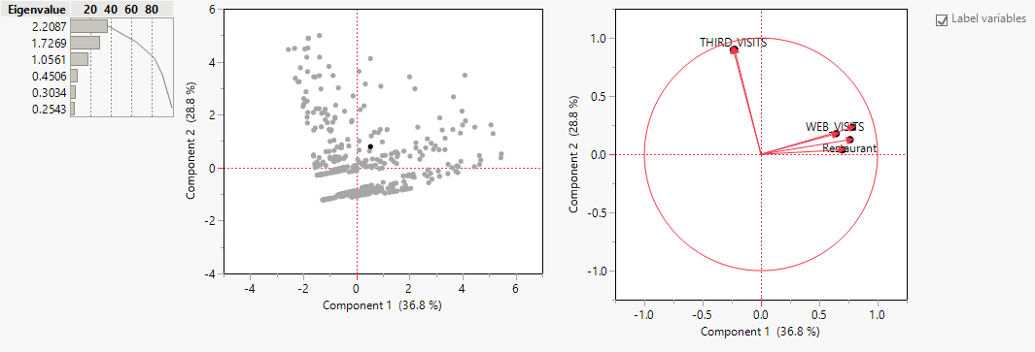

**Covariance Matrix**

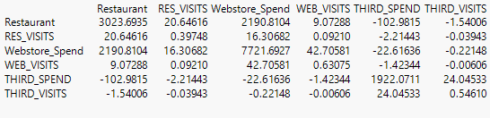

**Eigenvectors**

|  | **Prin1** | **Prin2** | **Prin3** | **Prin4** | **Prin5** | **Prin6** |
| --- | --- | --- | --- | --- | --- | --- |
| Restaurant | 0.51411 | 0.09599 | 0.43716 | -0.49929 | 0.52192 | 0.11692 |
| RES_VISITS | 0.46913 | 0.02870 | 0.53952 | 0.62353 | -0.30712 | -0.06996 |
| Webstore_Spend | 0.52785 | 0.17630 | -0.36091 | -0.40930 | -0.60618 | -0.15830 |
| WEB_VISITS | 0.43370 | 0.13488 | -0.61545 | 0.43787 | 0.45039 | 0.14271 |
| THIRD_SPEND | -0.16012 | 0.68415 | 0.07760 | 0.01286 | -0.17432 | 0.68536 |
| THIRD_VISITS | -0.15248 | 0.68748 | 0.05251 | 0.04993 | 0.18051 | -0.68285 |

